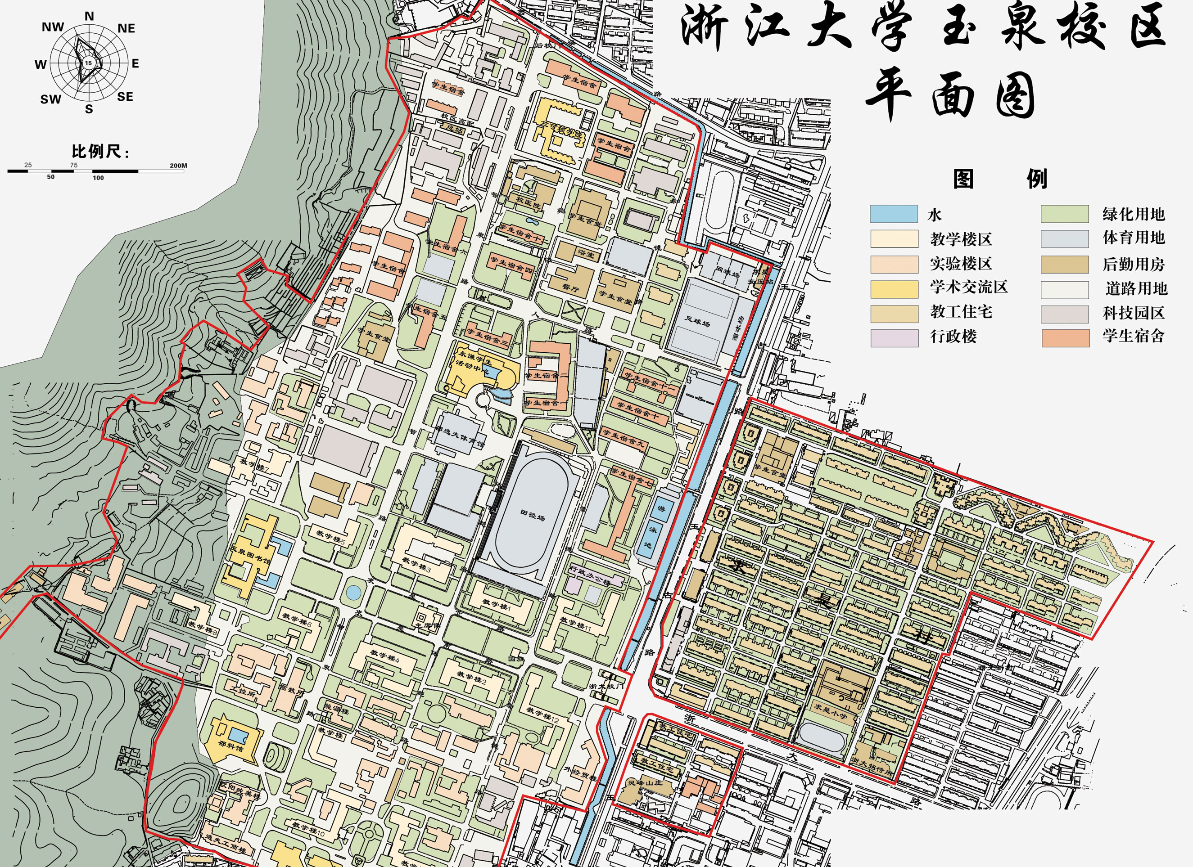
Lingfeng Hotel
Sir Run Run Shaw Science
Building
Sir Run Run Shaw Business Administration Building
Zhejiang University
Main Gate
Yugu Road
Zheda Road

